***Sport***

1] **Rules of a 200-Meter Sprint**

1. rules require 200 meter sprinters to use starting blocks.
2. Blocks are not allowed to touch the start line or any part of another runner's lane.
3. If the runner false starts once in 200 meter race, a race official will present him with a red card and he will be disqualified The from the race, according to the IAAF.

## **2] Rules For JAVELIN THROW**

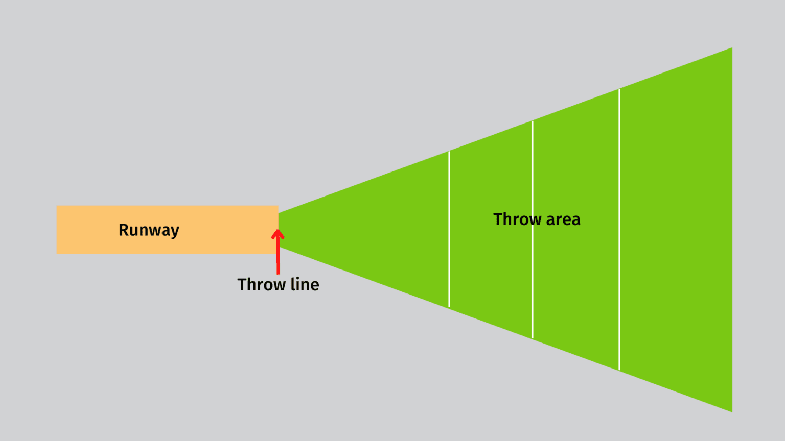

### **RUNWAY**

The javelin runway is 4 meters (13 feet) wide and 36 meters (118 feet) long. The players will run with the javelin down this runway before reaching the throw line, from which they must stop and toss the javelin.

### **THROW AREA**

The throw area is a triangular region of the field that starts from the runway and goes up to over 100 meters (330 feet), the field widens at a 29-degree angle. There are arced lines marking every 10 meters on the throwing area.

* **nREQUIREMENTS OF EQUIPMENT**

The length of the men’s javelin must be between 2.6 and 2.7 meters (8 feet 7 inches to 8 feet 10 inches), while the length of the women’s javelin must be between 2.2 and 2.3 meters (7 feet 3 inches to 7 feet 7 inches).

The minimum weight of a man’s javelin is 1.8 pounds, whereas a woman’s javelin weighs 1.3 pounds. Throwers wear shoes with spikes. A maximum of 11 spikes are allowed on the shoe, and they must be no longer than 12 mm (or .5 inches) and no wider than 4 mm (or .15 inches).

### **THROWING RULES**

1. The athlete must hold the javelin with one hand on the cord grip in order to throw it correctly.
2. Gloves are prohibited, and tape on the fingers is only acceptable to cover an open cut. Throwing the javelin requires an over-shoulder motion.
3. The javelin must be in the air before the contestant may turn away from the throwing location.

### **FOULS**

A referee places a white flag for a fair throw or a red flag for a foul after each throw. There are various kinds of fouls. A red flag means that the shot does not count, and the player cannot retry the attempt.

* A thrower’s foot touches outside the throw line.
* The javelin lands outside of the boundary lines.
* The player steps outside of the runway line.
* The javelin is thrown underarm.